2/21/2018

Roshnee Meena

EPITA

USER GUIDE

Identity Management Application

1. The identity management application can be used only by the authorised users.

1. When the application is started it goes to the login page. If you are an authorised user enter the credentials.

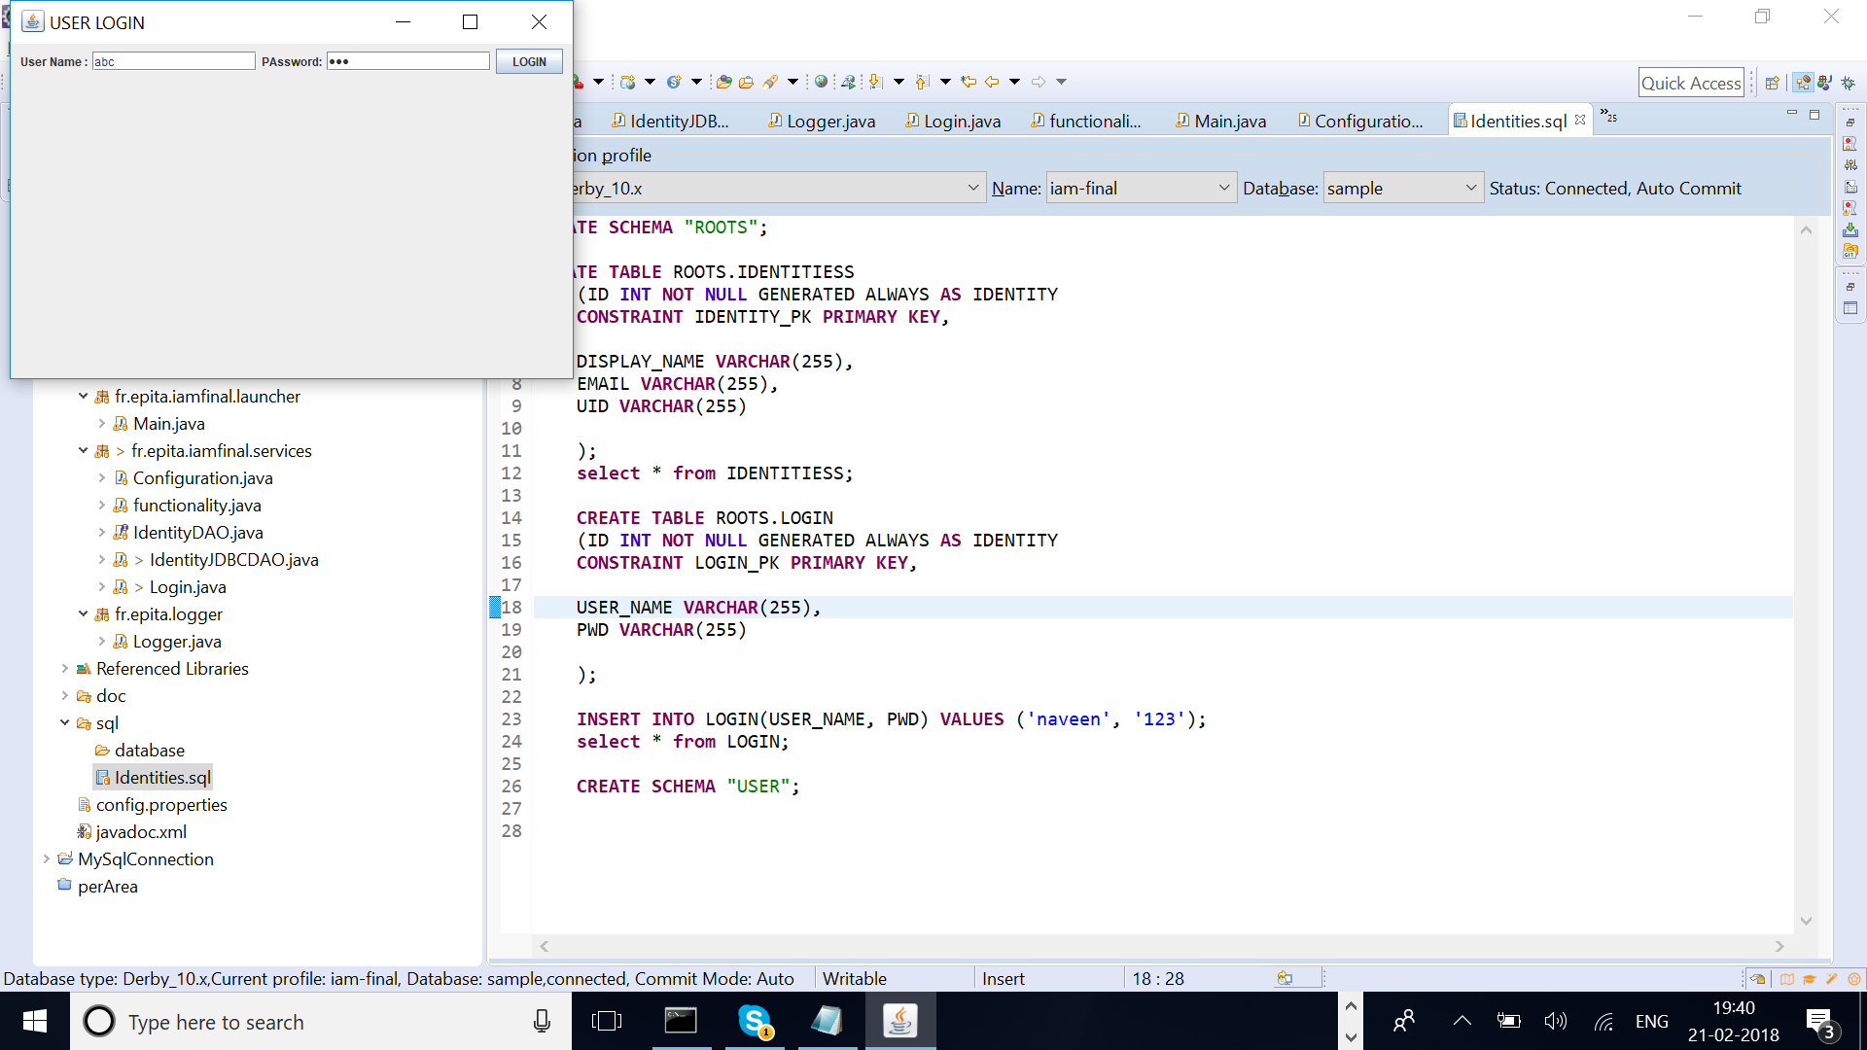

1. If the credentials are correct it will take you to the menu page which has four menus create, search, update and delete

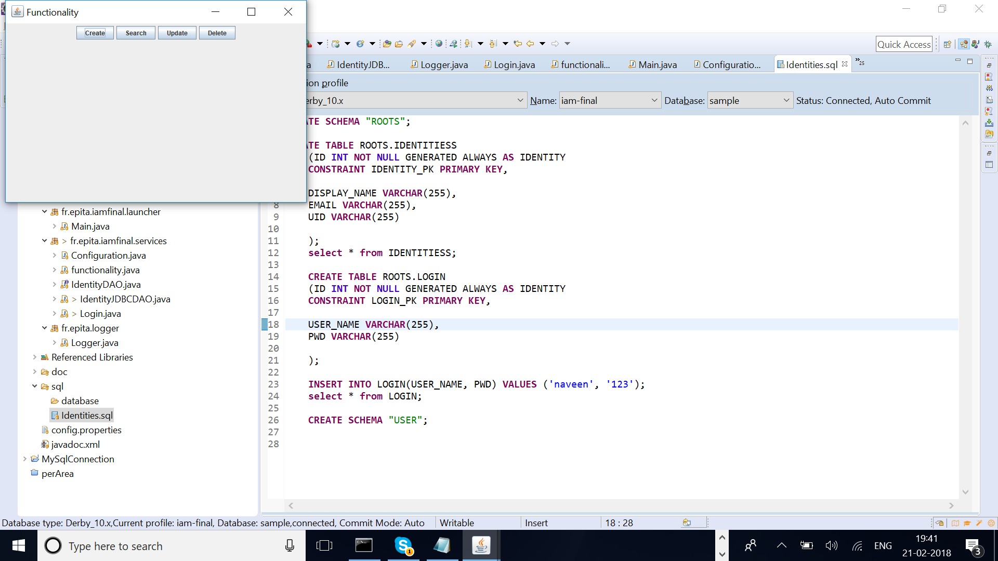

1. If the credentials are wrong you will be getting the below message

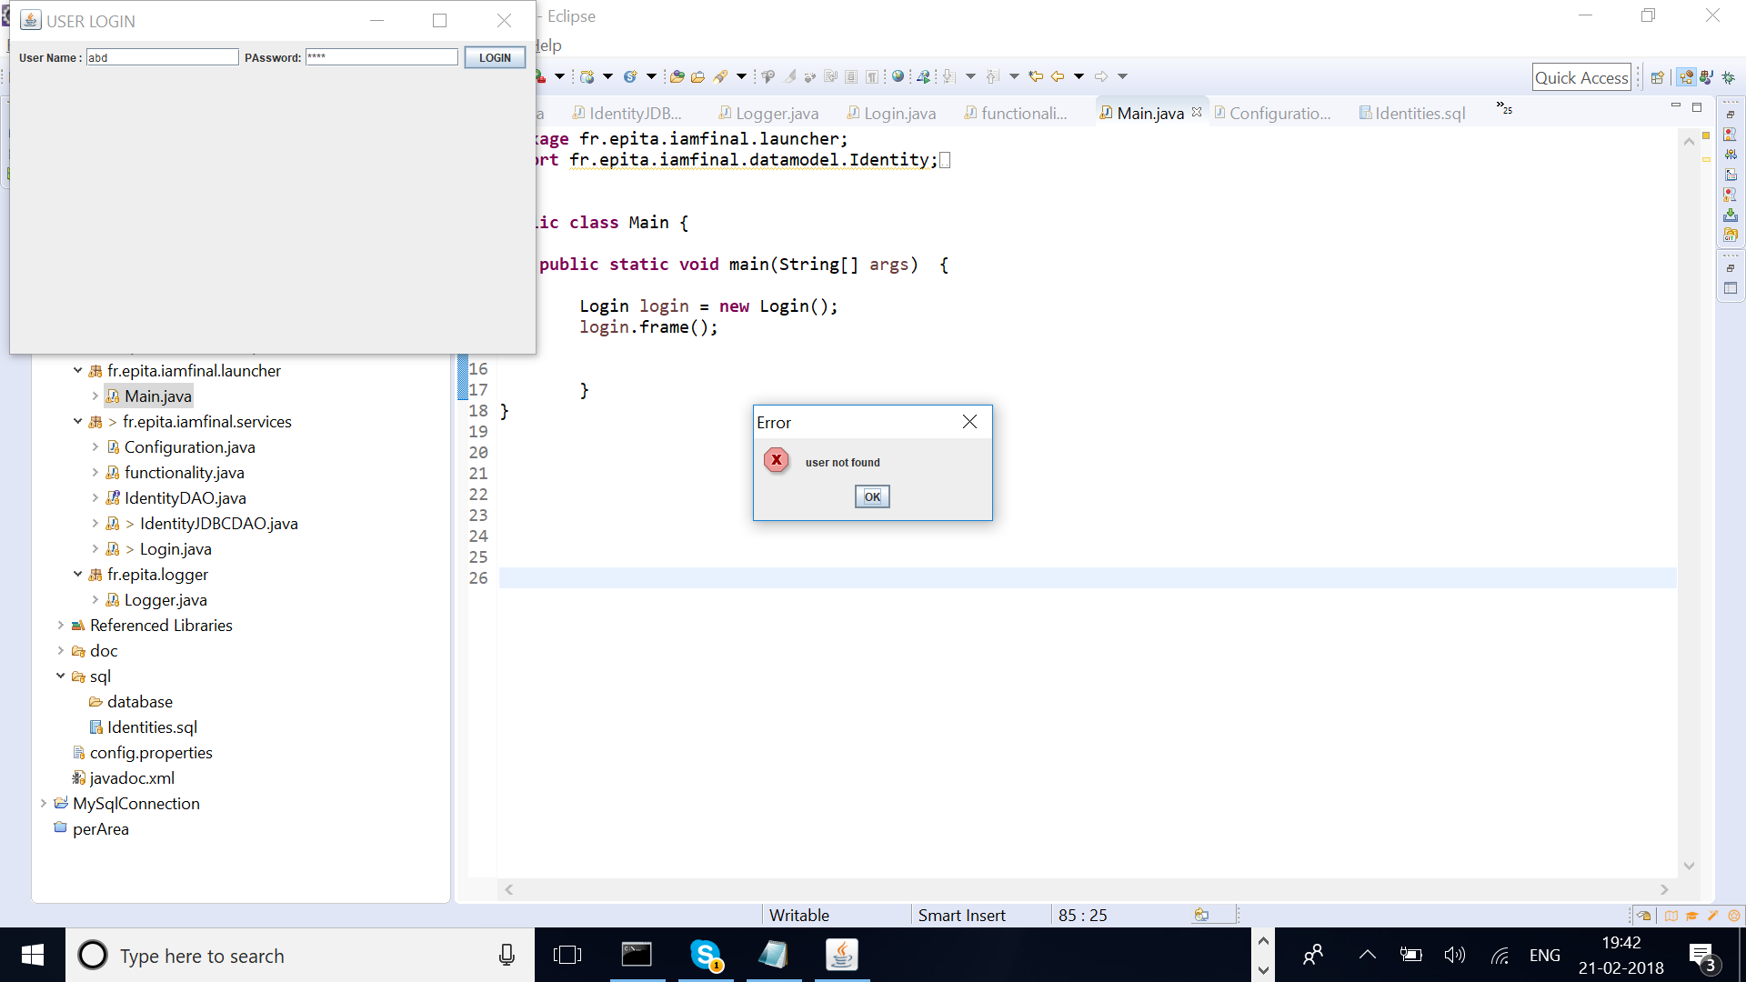

1. when u select the create option, create panel will ask you to enter the displayname, email and uid and the given identities will get inserted into the database. If some problem occurs it will be displayed in the console.

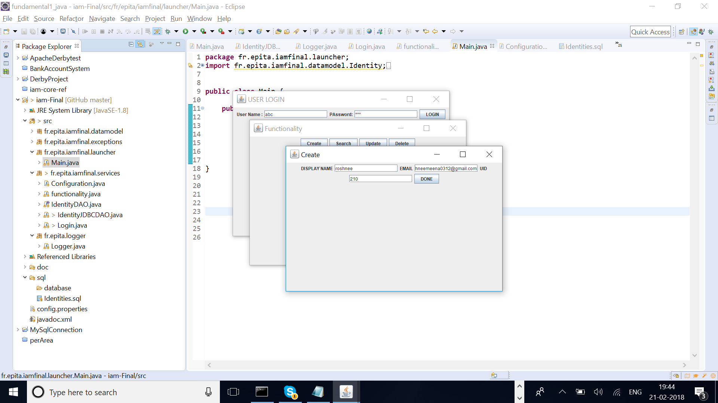

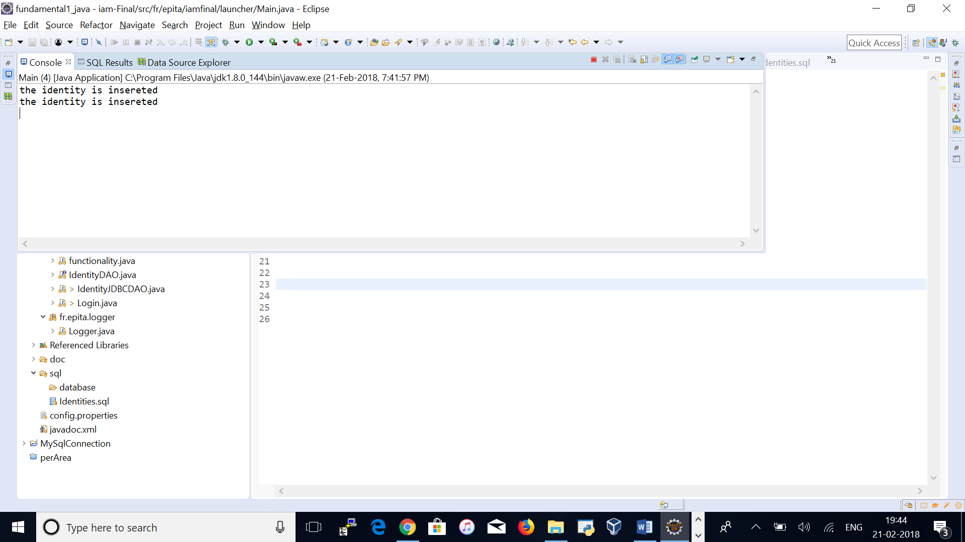

1. If you select the search option it will ask the identity details to be searched. If the identity is available in the table it will get displayed in the console else it will say “identities not available” in the console

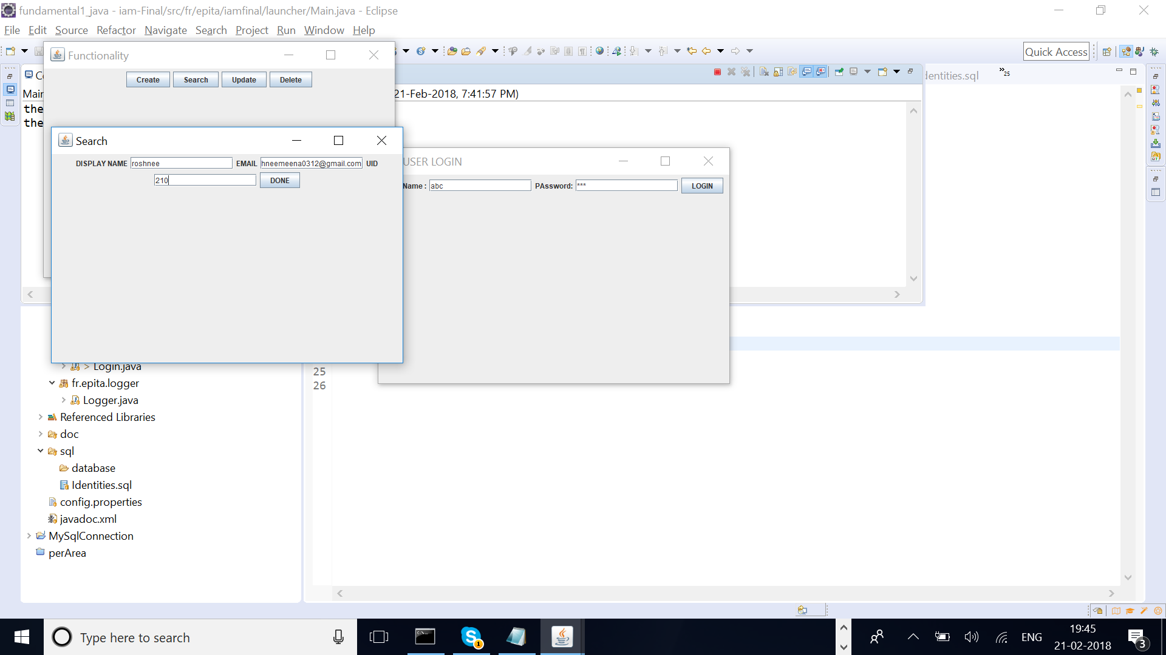

1. If you select the update option it will ask the identity to be updated and also the new identity details. If the identity is present it will update else it will display “Identity not available” in the console.



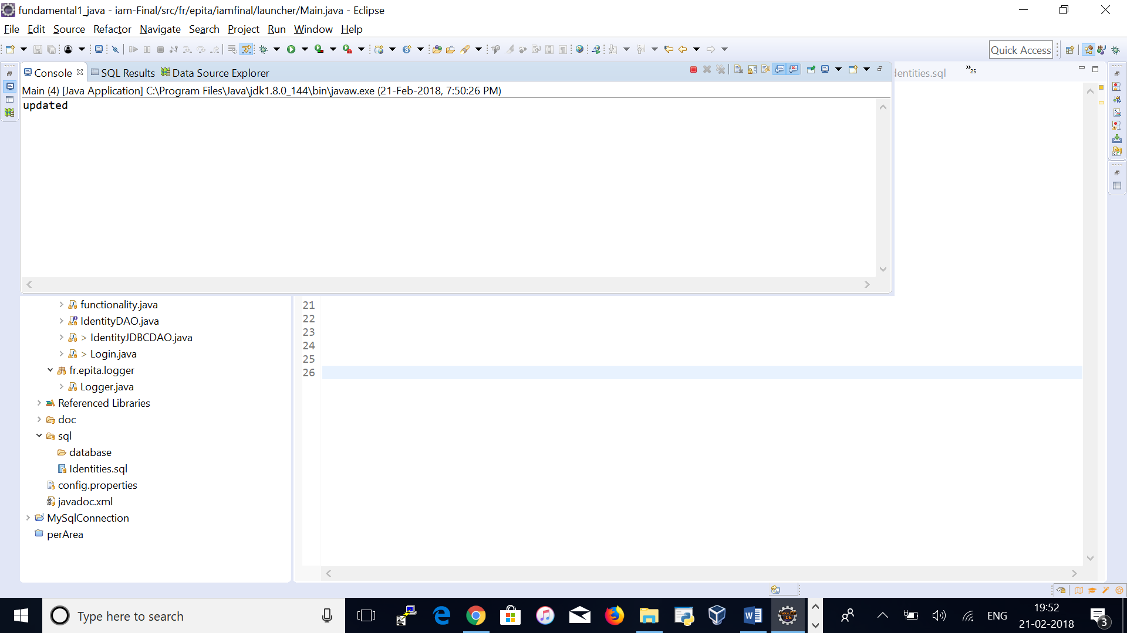

If the identity is not available in the table

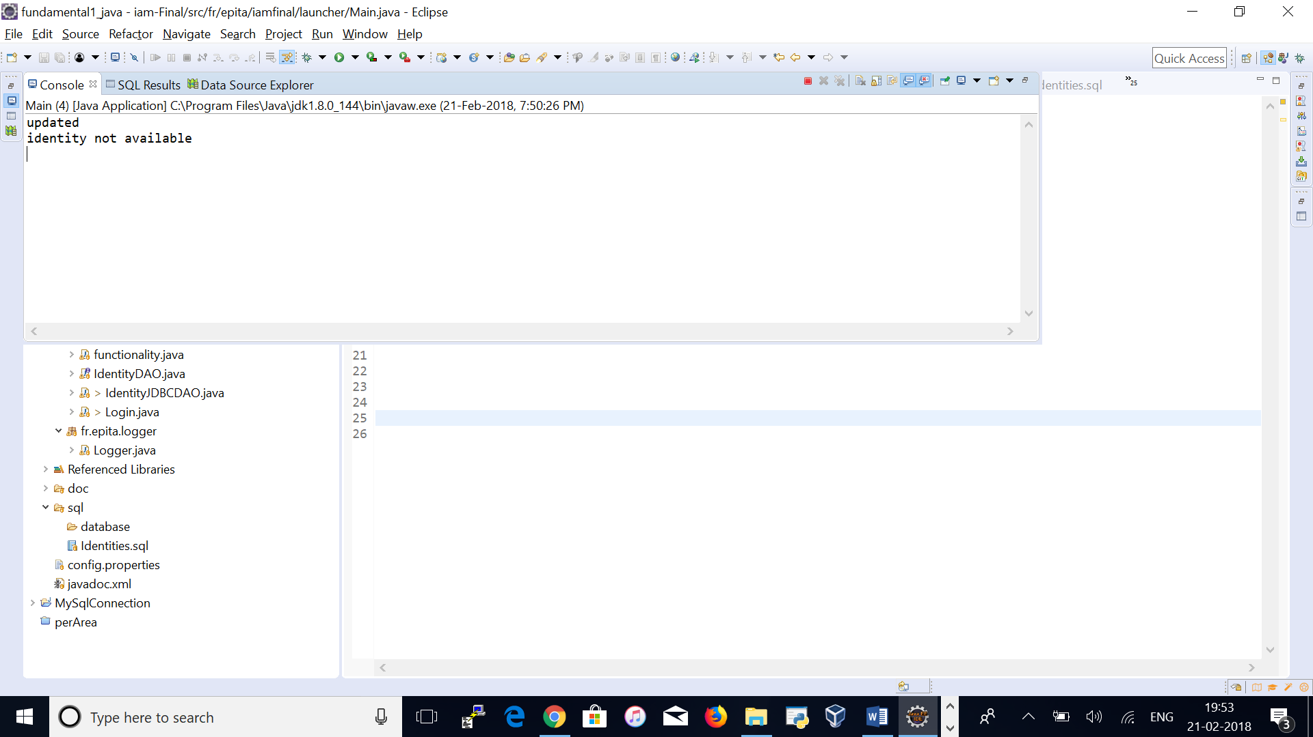

1. If you select the delete option it will ask the identity to be deleted. If the identity is already available it gets deleted else it will display “identity not available” in the console.

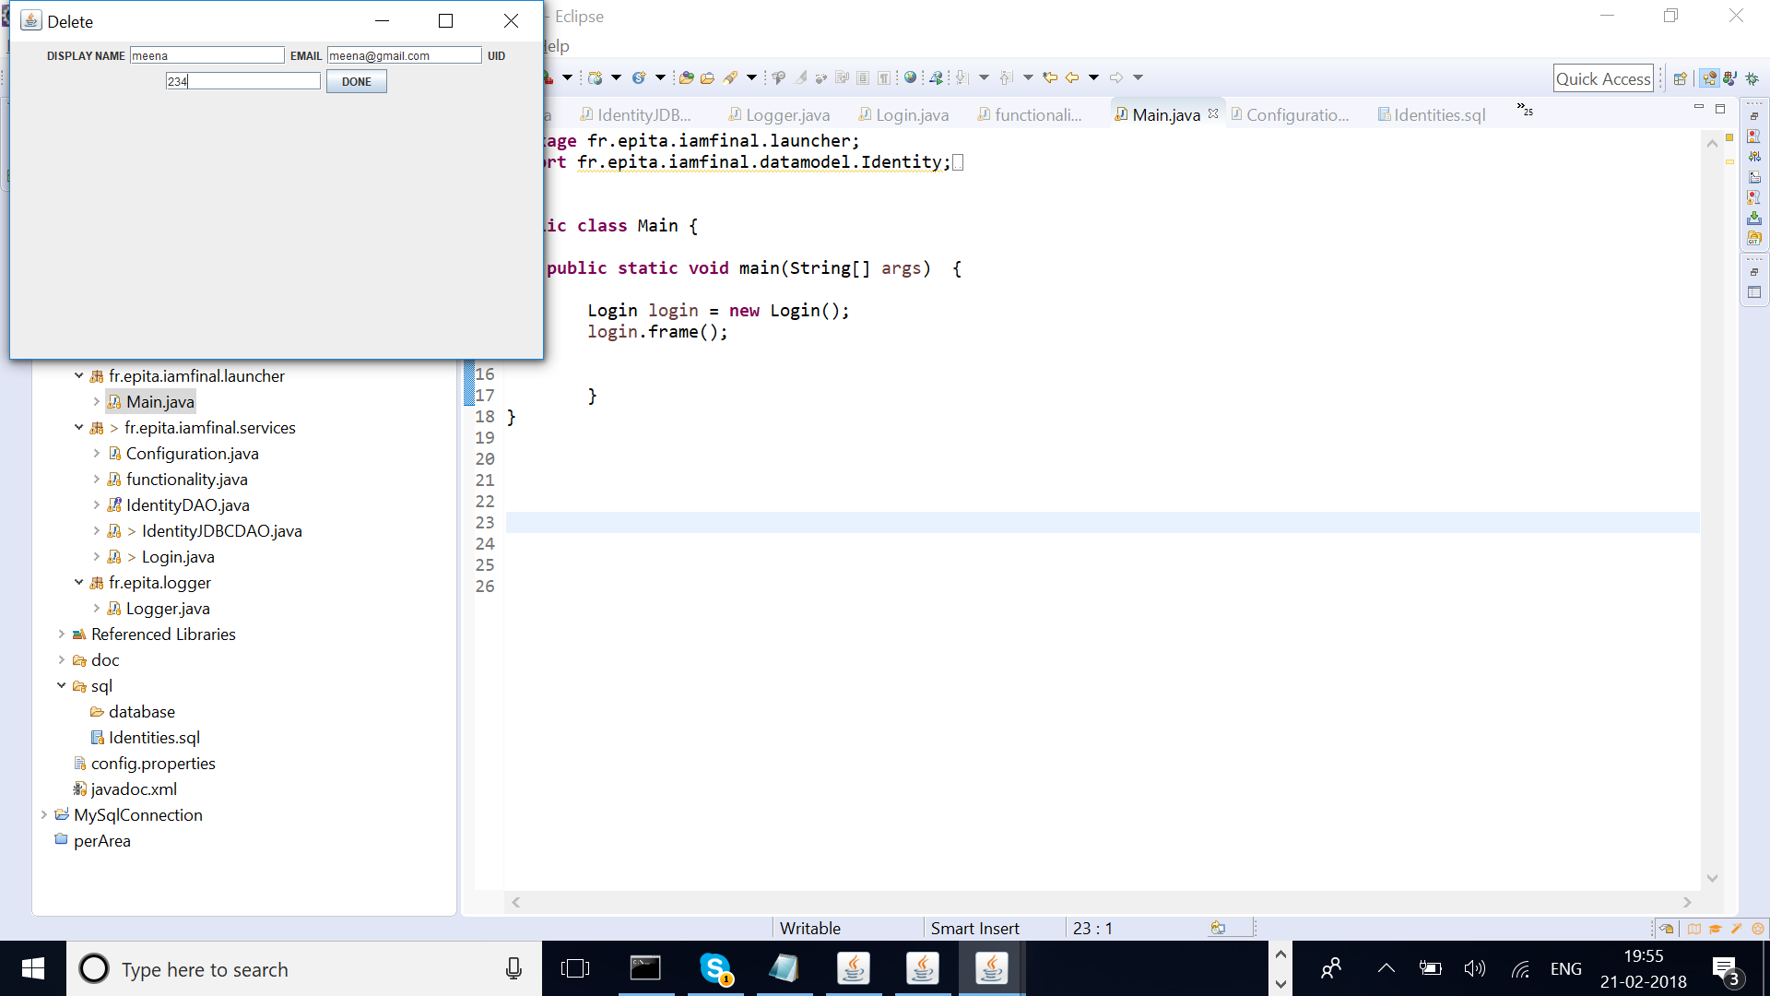

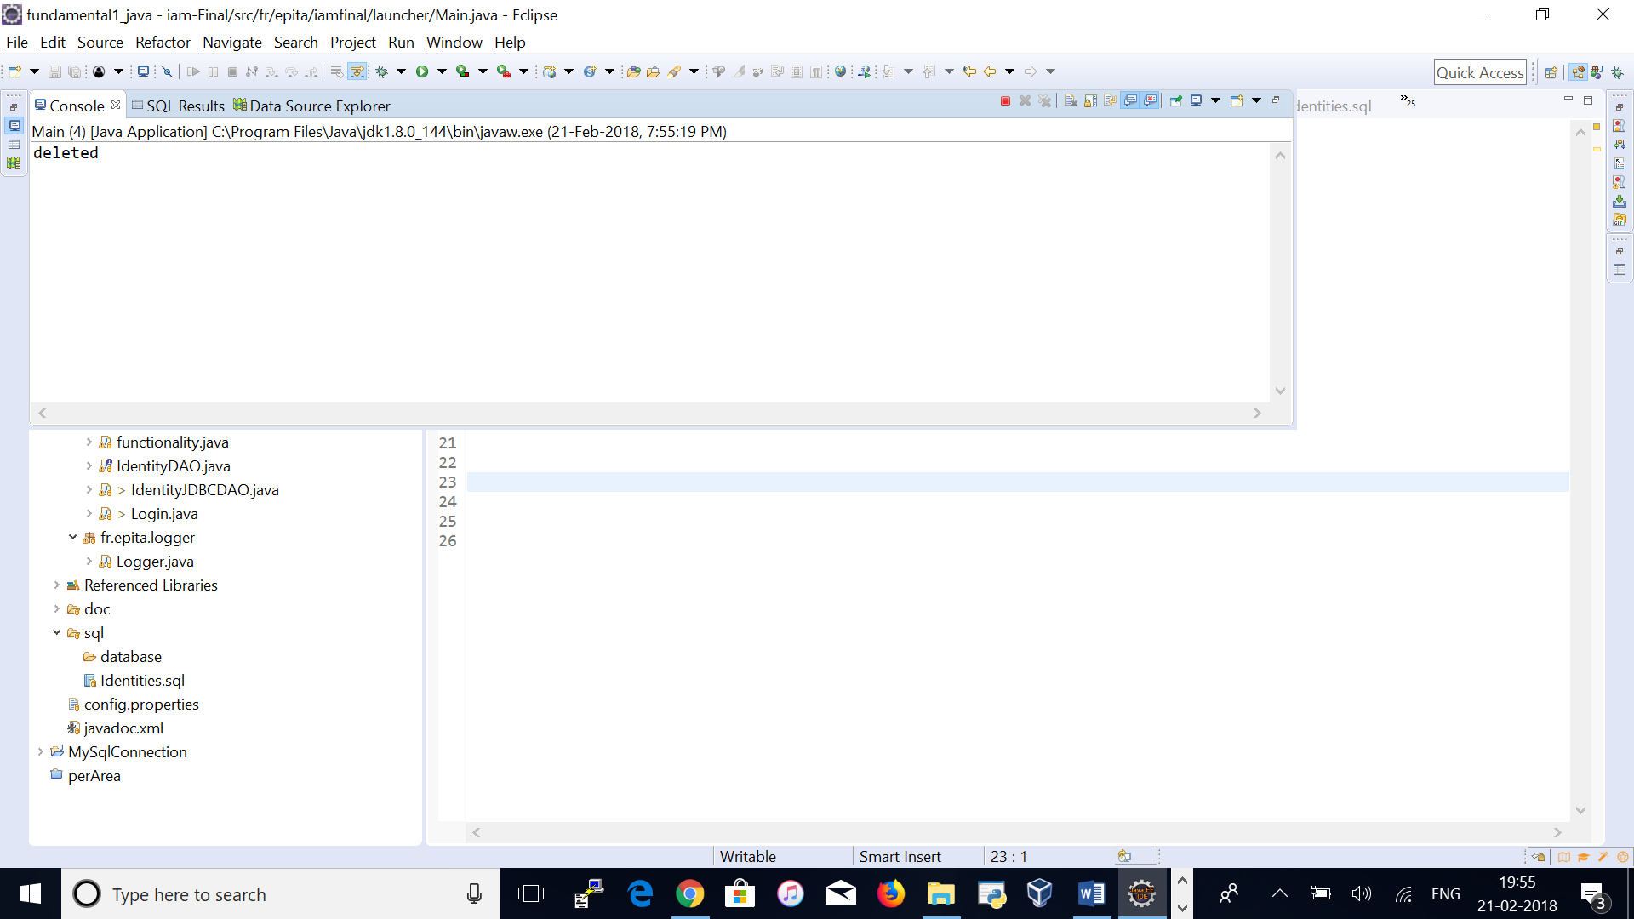

If the entered identity is not available

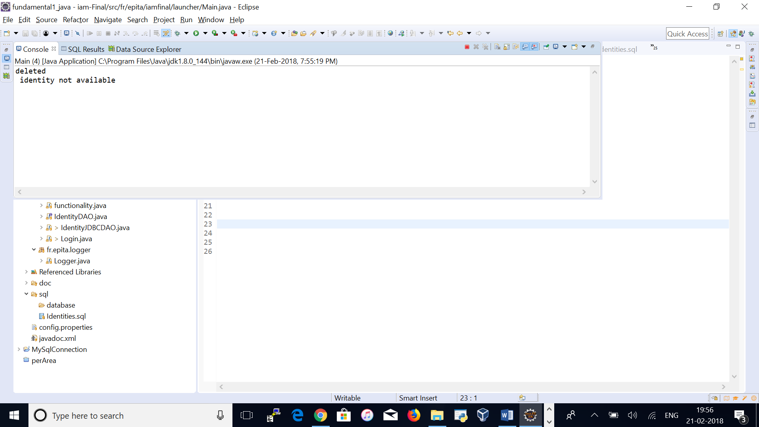

1. To close the panel press the ‘X’ button at the top corner.